Capstone Project Report

Scope:
Attacker: Kali Linux
Targets: DVWA web page

1 – Vulnerabilities Findings List
Target: DVWA

Vulnerability | PTES Phase
SQL Injection (sqli) | Scanning / Exploitation
Cross-Site Scripting (Reflected) | Recon / Exploitation
Cross-Site Scripting (Stored) | Recon / Exploitation
Command Injection | Exploitation
File Upload (unrestricted) | Exploitation
Local File Inclusion (LFI) | Recon / Exploitation
Remote File Inclusion (RFI) | Recon / Exploitation
Cross-Site Request Forgery (CSRF) | Exploitation / PostExploitation
Broken Authentication / Brute Force | Recon / Exploitation
Insecure Direct Object Reference (IDOR) | Exploitation
Insecure Cryptography / Weak Crypto | Recon / Reporting
Security Misconfiguration (default creds, verbose errors) | Recon / Exploitation
Insecure APIs / Missing Auth Checks | Recon / Exploitation

2 – Exploitation
Target: DVWA webpage Security: Low Description:
SQL injection to get list of users and there passwords

Query used:
- ‘ 1’ OR ‘1’=’1s (All true)
- ‘ ORDER BY 1#......n# (Untill returns error to find how many rows)
- ‘ UNION SELECT user, password FROM users#.(Union to select all user in rows and password from users row)
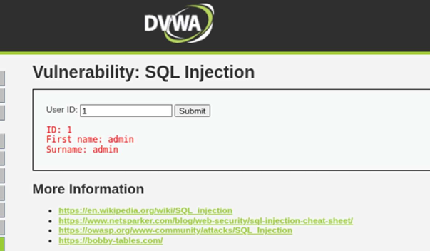
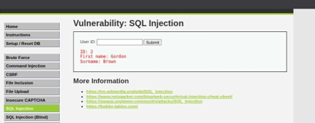
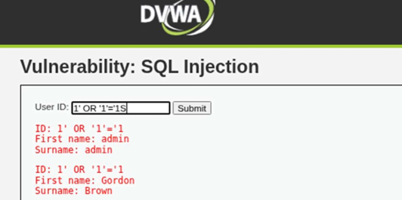
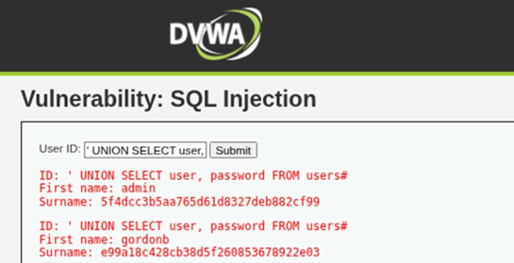

3 – Summary (Technical)

The penetration test followed the Penetration Testing Execution Standard (PTES) framework to assess the DVWA (Damn Vulnerable Web Application) for SQL Injection vulnerabilities. Using Kali Linux as the attacker machine and DVWA hosted locally, the focus was on identifying and exploiting input validation flaws in the login module.
During the reconnaissance and vulnerability analysis phases, manual testing and automated tools such as sqlmap was used to detect injectable parameters. The vulnerable field was found in the login form, which allowed direct manipulation of SQL queries. By injecting payloads such as ' OR '1'='1' – and ‘ ORDER BY, the tester was able to bypass authentication and gain unauthorized access to the admin panel.
This confirmed improper input sanitization and lack of parameterized queries. The impact includes unauthorized database access, credential exposure, and full compromise of the backend database.

4 – Summary (Non Technical)
A security test was performed on a vulnerable web application to simulate real-world cyberattacks. The test identified issues such as insecure input fields, poor data validation, and outdated software that could allow attackers to steal information or take control of the system. Tools like Nessus and sqlmap helped detect and confirm these weaknesses. Recommendations include regularly updating software, validating all user inputs, and using web security firewalls. After fixes are applied, a follow-up scan should be done to ensure all vulnerabilities are resolved and the system remains protected.

